Date:
Organization for Human Brain Mapping
Advancing Understanding of the Human Brain

Legal Name:

Current Address:

Dear

We cordially invite you to attend the 30th Annual Meeting of the Organization for Human Brain Mapping (OHBM). The event will be held June 23 - June 27, 2024 at the COEX Convention and Exhibition Center in Seoul, Korea. OHBM is the primary international organization dedicated to neuroimaging.
Each year, approximately 3,000 attendees gather to attend top-notch scientific educational programs, share their latest research, and network in the community. For further information regarding the event and the organization please visit our website: https://www.humanbrainmapping.org/
This letter of invitation is to facilitate your visa application. OHBM will not be providing financial support for this delegate including travel, registration fees or local expenses relative to the OHBM meeting. We advise all delegates to apply for their visa at least 12 weeks in advance of their departure date to ensure that they receive it in time to travel to the event.
Depending on where you live, you will need to meet certain entry requirements to visit Korea. If you need a K-ETA to visit Korea, please use the link below:
https://www.k-eta.go.kr/portal/apply/index.do
If you require a visa, please contact your local Republic of Korea embassy.
We look forward to welcoming you to Seoul!

Sincerely,

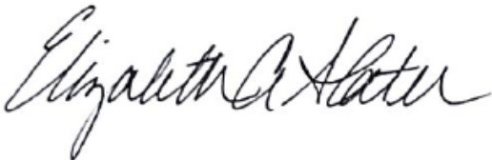

Elizabeth Slater,
Executive Director,
Organization for Human Brain Mapping,
1935 County Road B2 W, Suite 165
Roseville, MN, USA, 55113,
+1-952-641-3041

